A centre of ecological diversity . . . The montane of Beauvais Lake Provincial Park is host to over 140 species of birds, from Clark's nutcrackers, ruby-crowned kinglets, the common loon to osprey, bald eagles and great blue herons. Species such as the sandhill crane, which is classified as a sensitive species in SW Alberta, have been observed nesting in the area.

Park Habitats: Four major habitats are found in Beauvais Lake Provincial Park - fescue grasslands, wetlands, higher elevation Douglas fir, limber pine and spruce forest, and aspen woodlands. This checklist includes information on the residence status (RS) in column 1, the abundance (in habitat) (A) in column 2, and the habitats where species nest (NB) in column 3.
Legend

Residence Status (RS) first column:
S summer resident
W winter resident/visitor
Y year-round resident
V visitor/accidental
M migrant (spring and /or fall)

Abundance (in habitat) (A) second column:
V – very common: observers will have a very good chance of finding this species in its habitat.
C – common: observers will have a good chance of finding this species in its habitat.
R – rare: observers may find this species on a rare occasion in its habitat.
X – extremely rare: observers have a very rare chance of observing this type of bird in its habitat. Ensure your sighting is accurate and report it.

(NH) Primary Nesting Habitat third column:
G mixed-grass and fescue grasslands
W wetlands, streams, lakes and vicinity
A aspen woodlands
F Douglas fir, spruce and pine coniferous forests

LOONS

(RS) (A) (NH)
__ Common Loon S R W

GREBES
(RS) (A) (NH)
__ Red-necked Grebe S C W
__ Eared Grebe V R
__ Horned Grebe M X
__ Western Grebe M R

PELICANS AND CORMORANTS

__ American White Pelican V R
__ Double-crested Cormorant V R

HERONS AND BITTERNS

__ American Bittern V R
__ Great Blue Heron V C

SWANS, GEESE AND DUCKS

__ Tundra Swan M R
__ Canada Goose S V W
__ Wood Duck M X
__ Green-winged Teal S R W
__ Mallard S V W
__ Northern Pintail S R W
__ Blue-winged Teal S C W
__ Cinnamon Teal S C W
__ American Wigeon S R W
__ Ring-necked Duck S C W
__ Lesser Scaup S R W
__ Common Goldeneye M R
__ Barrow’s Goldeneye S R W
__ Bufflehead S R W
__ Hooded Merganser V X
__ Common Merganser V R
__ Ruddy Duck S R W

HAWKS EAGLES AND FALCONS

__ Turkey Vulture V X
__ Osprey S C W/F
__ Bald Eagle S C W/A/F
__ Northern Harrier S R W/G
__ Sharp-shinned Hawk S X A/F
__ Northern Goshawk Y R A/F
__ Broad-winged Hawk V X
__ Swainson’s Hawk S R G/A/F
__ Red-tailed Hawk S C F/A
__ Rough –legged Hawk M R
__ Golden Eagle V R
__ American Kestrel S R A/G
__ Merlin S R F/A
__ Peregrin Falcon V X
__ Gyrfalcon V X
__ Prairie Falcon V R

GROUSE, PHEASANTS, ALLIES

__ Spruce (Franklin's) Grouse Y R A/
__ Blue Grouse Y R G/A/F
__ Ruffed Grouse Y C A/F
__ Sharp-tailed Grouse Y R G/A

RAILS AND COOTS

__ Sora S C W
__ American Coot S C W
__ Sandhill Crane S R W

SHOREBIRDS AND GULLS

__ Killdeer S C W
__ Greater Yellowlegs M R
__ Lesser Yellowlegs M R
__ Solitary Sandpiper V X
__ Spotted Sandpiper S C W
__ Semipalmated Sandpiper M R
__ Least Sandpiper M R
__ Longbilled Dowitcher M X
__ Wilson's Snipe (formally Common) S C W
__ Ring-billed Gull V C
__ California Gull V V
__ Caspian Tern V X
__ Common Tern S R W
__ Forster's Tern V X
__ Black Tern S C W

PIGEONS AND DOVES

__ Mourning Dove S C F/A

OWLS

__ Great Horned Owl Y C F/A
__ Barred Owl V X
__ Great Gray Owl Y X A/F
__ Short-eared Owl M X
__ Boreal Owl Y X W/F
__ Northern Saw-whet Owl Y R F/A
__ Northern Pygmy Owl V X
GOATSUCKERS

__ Common Nighthawk S C A/G

HUMMINGBIRDS

__ Ruby-throated Hummingbird V X
__ Calliope Hummingbird S R A/F
__ Rufous Hummingbird S R A/F

KINGFISHERS AND WOODPECKERS

__ Belted Kingfisher S C W
__ Yellow-bellied Sapsucker S R A
__ Red-naped Sapsucker S C A
__ Downy Woodpecker Y C A
__ Hairy Woodpecker Y C A
__ Three-toed Woodpecker Y R F
__ Blackbacked Woodpecker Y X F
__ Northern Flicker S C A/F
__ Pileated Woodpecker Y R A/F

PERCHING BIRDS

Flycatchers
__ Olive-sided Flycatcher S R W/F
__ Western Wood Pewee S C A/F
__ Alder Flycatcher S R A/W
__ Willow Flycatcher S R A/W
__ Least Flycatcher S C A
__ Dusky Flycatcher S R A/F
__ Say’s Phoebe S R G/A
__ Eastern Kingbird S C G/A
Larks
__ Horned Lark Y R G
Swallows
__ Tree Swallow S C A/FW
__ Violet-green Swallow S R A/F/W
__ Northern Rough-winged Swallow S R A/F/W
__ Bank Swallow S R G/A/W
__ Cliff Swallow S R W
__ Barn Swallow S C G/A

Jays, Crows and Allies
__ Gray jay Y C A/F
__ Steller's jay V R
__ Blue jay V R
PERCHING BIRDS continued . . .

Jays, Crows and Allies continued . . .
__ Clark’s nutcracker Y C F
__ Black-billed magpie Y C A/F
__ American crow S C F
__ Common raven Y C F/W

Chickadees
__ Black-capped Chickadee Y C A/F
__ Mountain Chickadee Y C A/F
__ Boreal Chickadee Y R A/F

Nuthatches
__ Red-breasted Nuthatch Y V A/F
__ White-breasted Nuthatch W R A/F

Creepers
__ Brown Creeper Y R A/F

Wrens
__ House Wren S C A/F
__ Winter Wren S R F
__ Marsh Wren S R W
__ American Dipper S R W

Kinglets, Thrushes and Bluebirds
__ Golden-crowned Kinglet Y C F
__ Ruby-crowned Kinglet S C A/F
__ Mountain Bluebird S C A/G
__ Townsend’s Solitaire S R A/F
__ Veery S R A
__ Grey-cheeked Thrush M R
__ Swainson’s Thrush S C A/F
__ Hermit Thrush S R F
__ American Robin S V A/F
__ Varied Thrush S R F
__ Gray Catbird S X A

Pipits
__ American Pipit M R

Waxwings
__ Bohemian Waxwing W R
__ Cedar Waxwing S C A/F

Shrikes
__ Northern Shrike W R

Starlings
__ European Starling S C A

Vireos
__ Cassin's Vireo S R A/F
__ Warbling Vireo S C A
__ Red-eyed Vireo S X A

Wood Warblers
__ Tennessee Warbler M R
__ Orange-crowned Warbler S R A
__ Yellow Warbler S V A
__ Magnolia Warbler M R
__ Yellow-rumped Warbler S C F
__ Townsend’s Warbler M R
__ Blackpoll Warbler M R
__ Palm Warbler M X
__ American Redstart S R A/F
__ Ovenbird S R A/F
__ Northern Waterthrush S R A/W
__ MacGillivray’s Warbler S R A
__ Common Yellowthroat S V A/W
__ Wilson’s Warbler S X A

Tanagers
__ Western Tanager S R A/F

Grosbeaks and Buntings
__ Black-headed Grosbeak S R A
__ Rose-breasted Grosbeak M R
__ Lazuli Bunting S R A/F

Towhees, Sparrows and Longspurs
__ Chipping Sparrow S V A
__ Clay-coloured Sparrow S C A
__ Vesper Sparrow S C G
__ Savannah Sparrow S C G
__ Song Sparrow S R A/W
__ Lincoln's Sparrow S C A/W
__ White-throated Sparrow M R
__ White-crowned Sparrow S V A
__ Dark-eyed Junco S C F/A

Meadowlarks, Blackbirds and Orioles
__ Red-winged Blackbirds S V W
__ Western Meadowlark S R G
__ Yellow-headed Blackbird S C W
__ Brewer’s Blackbird S R A
__ Common Grackle S R A
__ Brown-headed Cowbird S C G/A
__ Baltimore Oriole S R A

Finches
__ Rosy Finch W R
__ Pine Grosbeak W R
__ Purple Finch V R
__ Cassin’s Finch S X A/F
__ Red Crossbill Y R A/F
__ White-winged Crossbill Y R A/F
__ Common Redpoll W R
__ Pine Siskin Y C A/F
__ American Goldfinch S C A/W
__ Black-headed Grosbeak
__ Evening Grosbeak Y R F

For More Information

We are interested in updating this checklist, and would like to hear from you if you can provide any new information or sighting records. If you have any comments or questions, drop by the park office, phone or email:
Beauvais Lake Provincial Park
Box 1420
Pincher Creek, Alberta
Canada T0K 1W0

beauvaislakeinfo@gov.ab.ca

Park office summer only: (403) 627-2021
Education & Interpretation: (403) 627-1152
Conservation Officer: (403) 627-1116

www.cd.gov.ab.ca/parks/beauvaislake/

To report a sighting include your name, phone number or email address, experience level, a detailed description of the bird, its behavior and habitat. If you can take a photograph without disturbing the bird, do so and include it with your report. Thank you to all the volunteer birders who have contributed to the accuracy of this list!

Last update: January 2003


BIRD CHECKLIST
Beauvais Lake Provincial Park

Over 180 bird species have been observed in Beauvais Lake Provincial Park. Along with your field guide, this checklist will help you enjoy your bird-watching experience in the park and surrounding area.
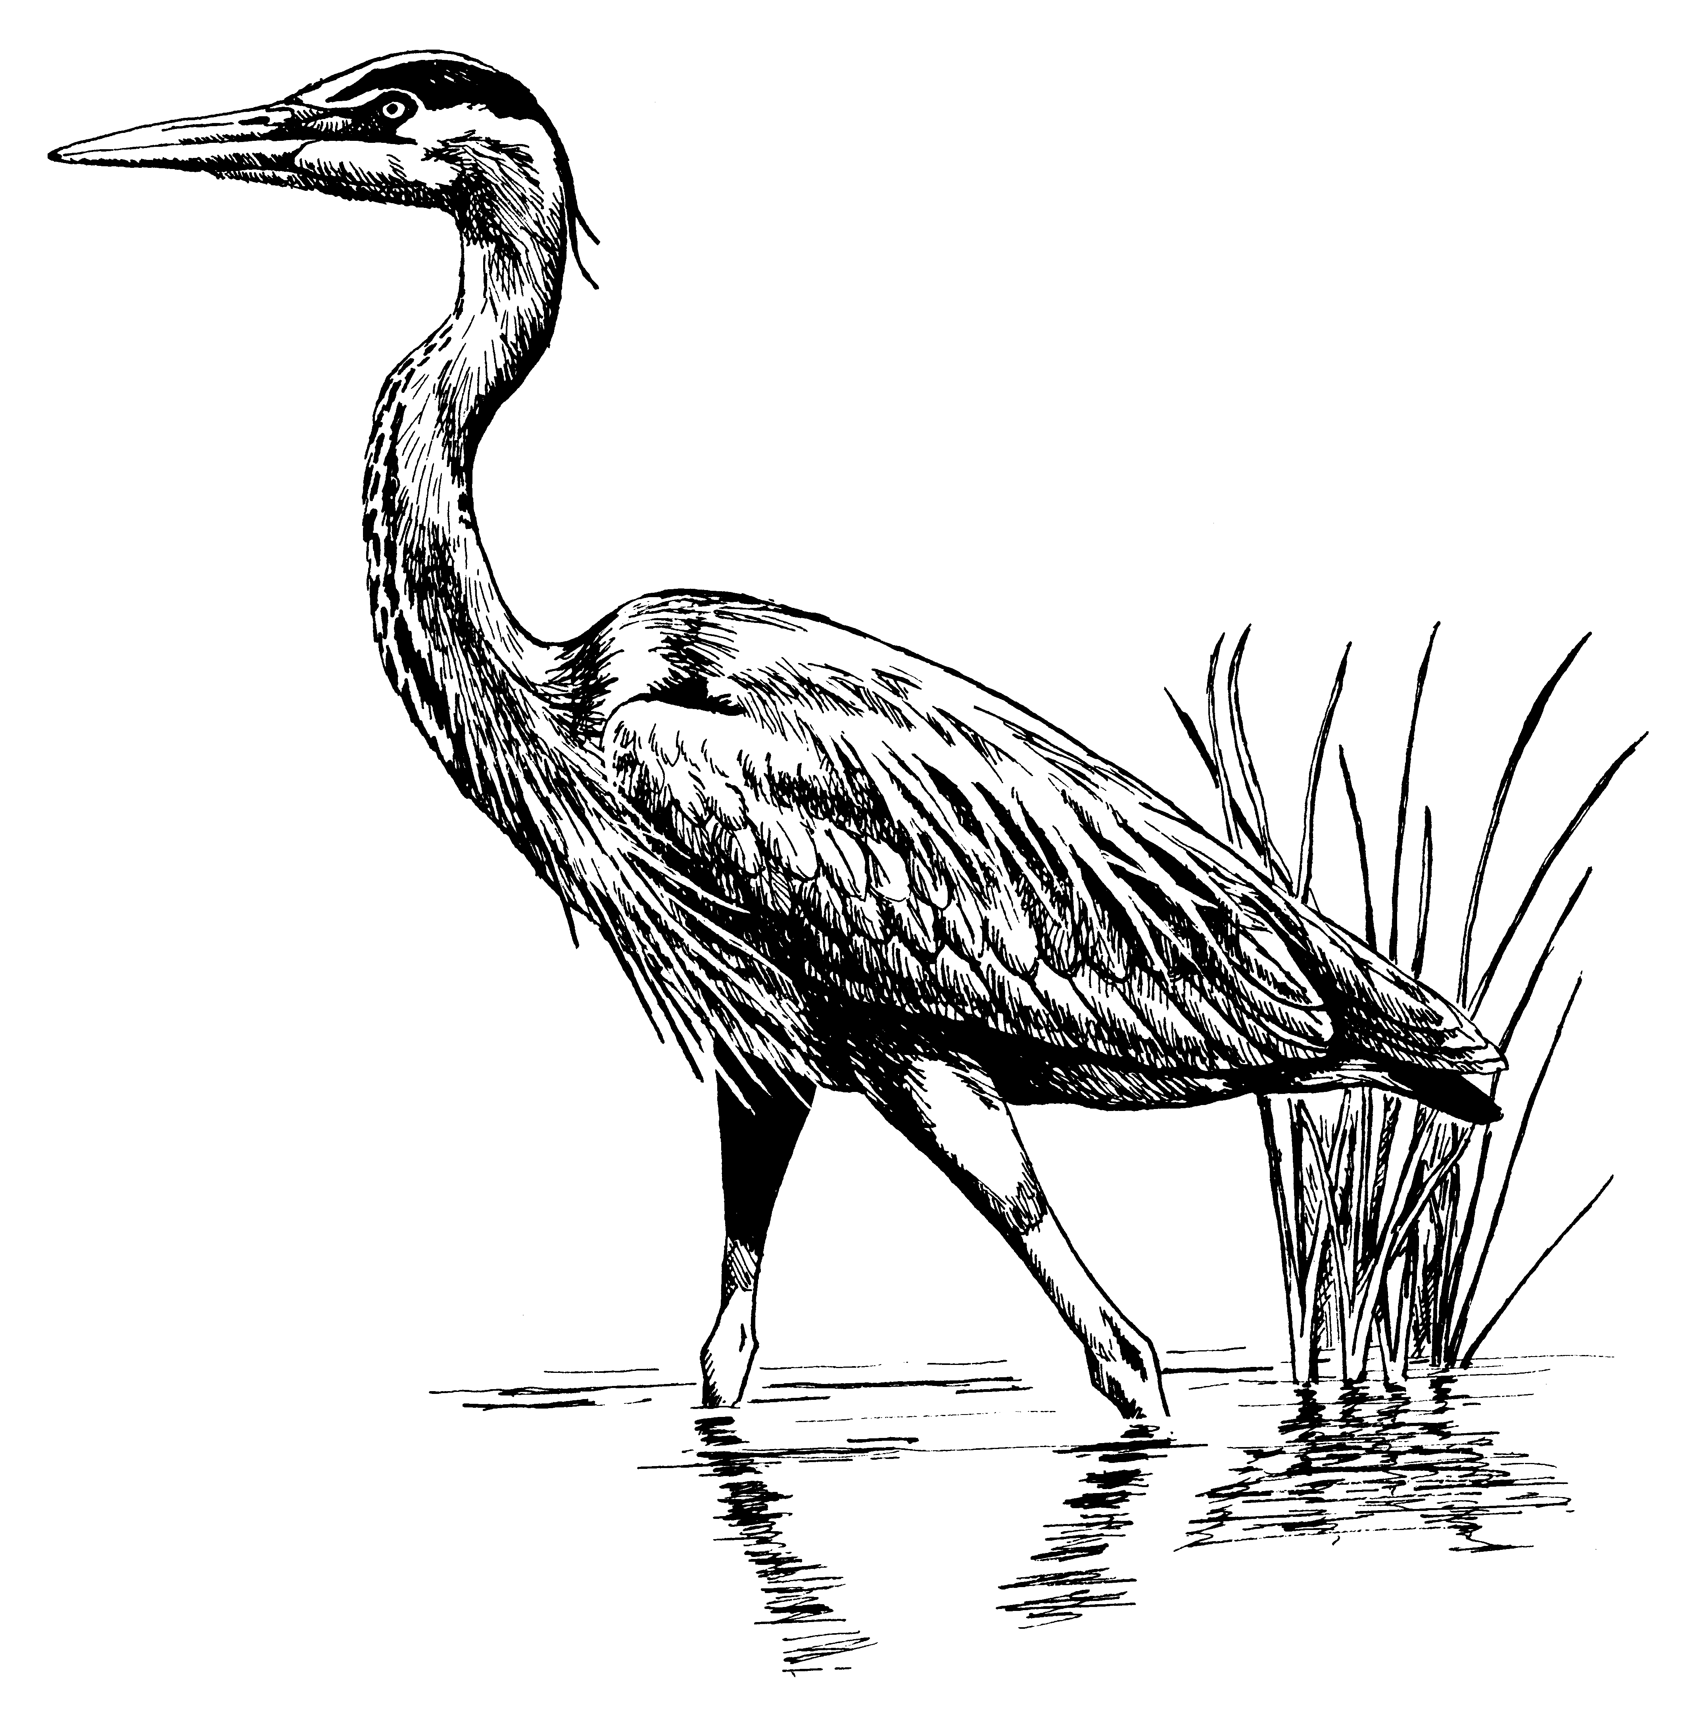

The southeast end of Beauvais Lake is a critical nesting area and is closed to all boating from April 1 to July 10 annually. Bird watchers and other hikers can walk to the area and observe wildlife from the new boardwalk. Park at Scott's point and follow the track SE from the parking lot. Thank you for supporting the park by reporting unusual sightings and helping to compile this checklist

